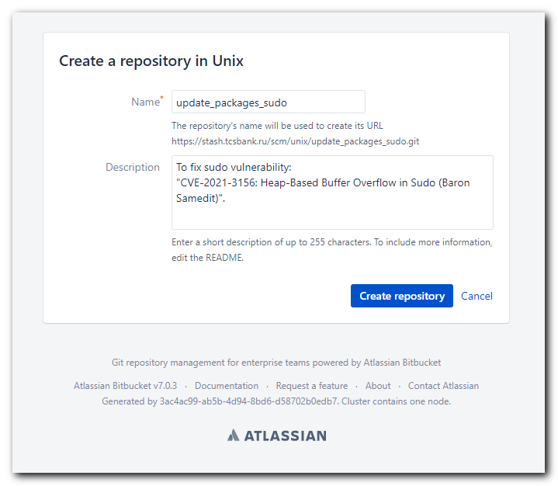

https://stash.tcsbank.ru/projects/UNIX/repos/update_packages_sudo/browse

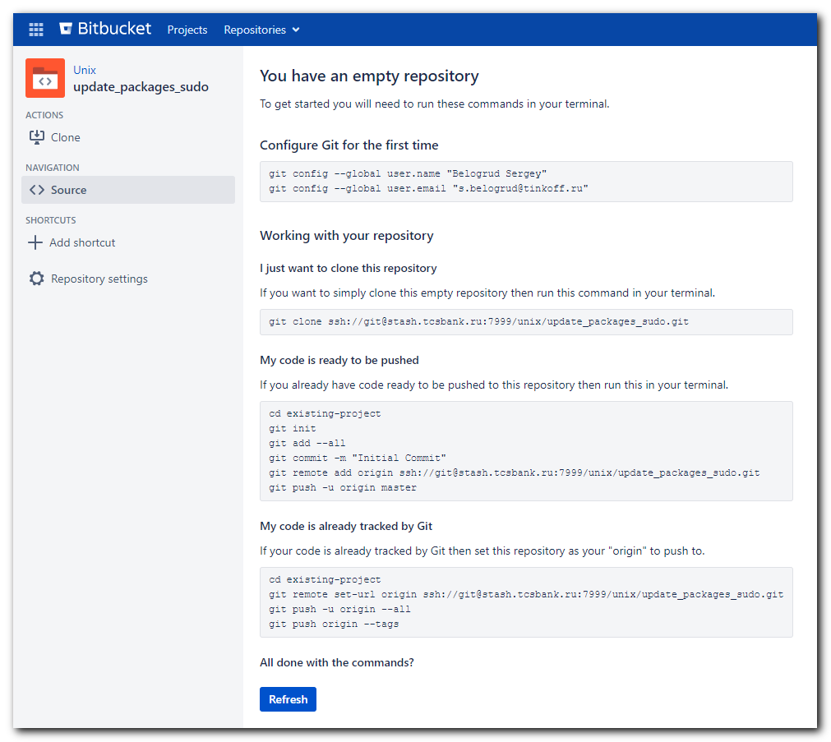

You have an empty repository
To get started you will need to run these commands in your terminal.
New to Git? Learn the basic Git commands

Configure Git for the first time
git config --global user.name "Belogrud Sergey"
git config --global user.email "s.belogrud@tinkoff.ru"

Working with your repository

I just want to clone this repository
If you want to simply clone this empty repository then run this command in your terminal.
git clone ssh://git@stash.tcsbank.ru:7999/unix/update_packages_sudo.git

My code is ready to be pushed
If you already have code ready to be pushed to this repository then run this in your terminal.
cd existing-project
git init
git add --all
git commit -m "Initial Commit"
git remote add origin ssh://git@stash.tcsbank.ru:7999/unix/update_packages_sudo.git
git push -u origin master

My code is already tracked by Git
If your code is already tracked by Git then set this repository as your "origin" to push to.
cd existing-project
git remote set-url origin ssh://git@stash.tcsbank.ru:7999/unix/update_packages_sudo.git
git push -u origin --all
git push origin --tags

All done with the commands?

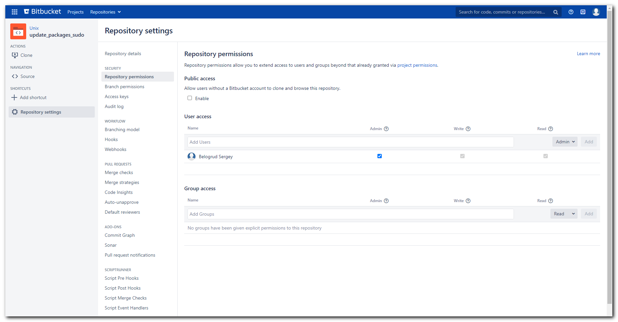

# And made repository public! This option allow clone it without login to this website!
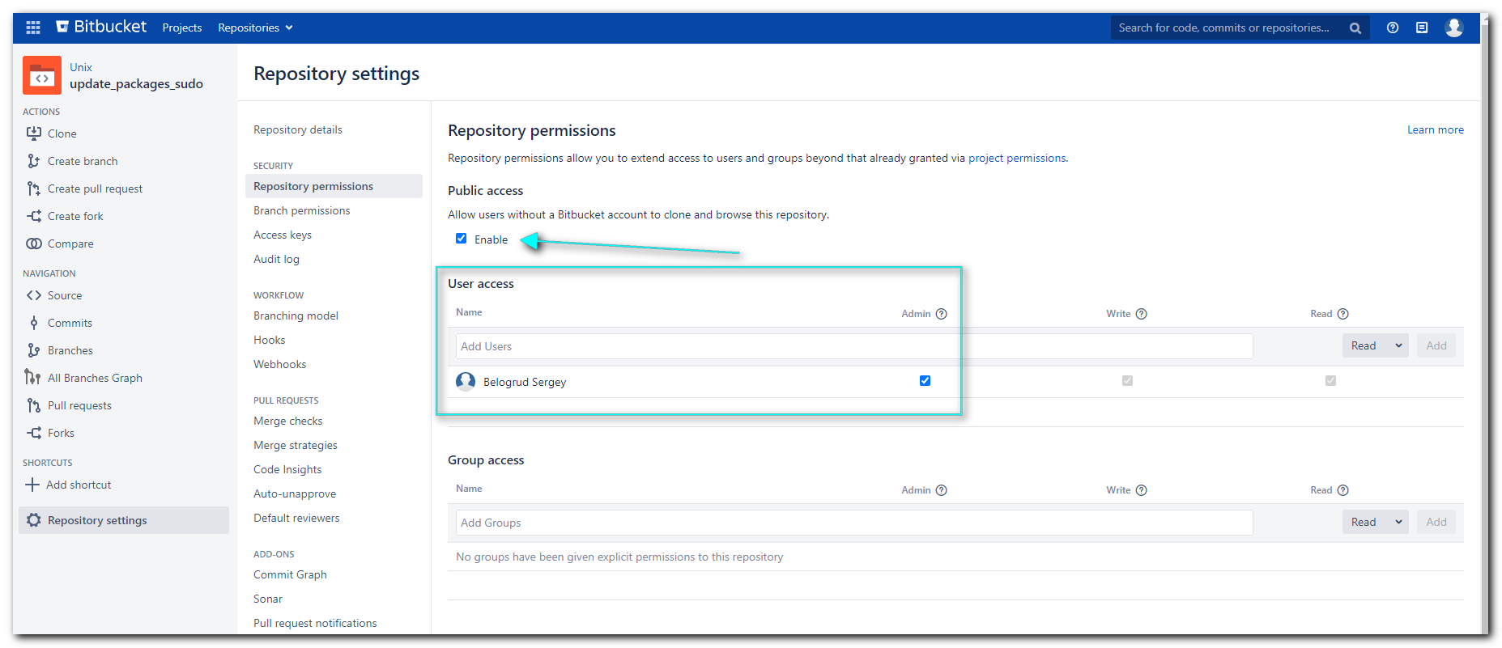

[s.belogrud@TCS4357]# cd /drives/c/share/work/ansible/stash.tcsbank.ru/roles/unix/update_packages
[s.belogrud@TCS4357]# cd ..
[s.belogrud@TCS4357]# ll
total 14
dr-xr-x--- 1 s.belogr UsersGrp 0 Oct 7 15:27 dco.common.repo
dr-xr-x--- 1 s.belogr UsersGrp 0 Oct 8 16:45 msp-scm
dr-xr-x--- 1 s.belogr UsersGrp 0 Aug 24 17:51 msp-scm-old
dr-xr-x--- 1 s.belogr UsersGrp 0 Nov 24 17:10 update_packages
[s.belogrud@TCS4357]# mkdir update_packages_sudo

#
# К сожалению git clone создаёт в винде каталог репозитория с корявыми правами. При открытии свойств каталога и попытке просмотра прав на него даже винда ругается, что права дурацкие.
# Это приводит к проблеме редактирования файлов в этом каталоге из PyCharm.
# Появляется такая ошибка, что отредактированный файл нельзя сохранить!
#
Cannot save C:\share\work\ansible\stash.tcsbank.ru\roles\unix\update_packages_sudo\tasks\ubuntu.yml.
Unable to create a backup file (ubuntu.yml~).
The file left unchanged.
#
# В итоге я в проводнике виндовом переименовал созданный каталог. Создал каталог с нужным именем.
# И старый удалил. Предварительно скопировав в новый нужное содержимое (из гитового полезен был лишь .git/config), остальное были файлы которые я успел подредактировать и лишние поудалять.
#
#
[s.belogrud@TCS4357]# git clone ssh://s.belogrud@stash.tcsbank.ru:7999/unix/update_packages_sudo.git
Клонирование в «update_packages_sudo»…
stty: standard input: Inappropriate ioctl for device
warning: Похоже, что вы клонировали пустой репозиторий.
[s.belogrud@TCS4357]# ls -Alh
total 14
dr-xr-x--- 1 s.belogr UsersGrp 0 Oct 7 15:27 dco.common.repo
dr-xr-x--- 1 s.belogr UsersGrp 0 Oct 8 16:45 msp-scm
dr-xr-x--- 1 s.belogr UsersGrp 0 Aug 24 17:51 msp-scm-old
dr-xr-x--- 1 s.belogr UsersGrp 0 Nov 24 17:10 update_packages
drwxr-xr-x 1 s.belogr UsersGrp 0 Feb 5 16:48 update_packages_sudo
[s.belogrud@TCS4357]#

[s.belogrud@TCS4357]# vim -o update_packages/.git/config update_packages_sudo/.git/config
2 files to edit
[s.belogrud@TCS4357]# cat update_packages_sudo/.git/config
[core]
repositoryformatversion = 0
filemode = true
bare = false
logallrefupdates = true
ignorecase = true
[remote "origin"]
url = ssh://s.belogrud@stash.tcsbank.ru:7999/unix/update_packages_sudo.git
fetch = +refs/heads/*:refs/remotes/origin/*
[branch "master"]
remote = origin
merge = refs/heads/master
[user]
name = Sergey Belogrud
email = s.belogrud@tinkoff.ru
[s.belogrud@TCS4357]#

[s.belogrud@TCS4357]# cp -R update_packages/* update_packages_sudo/
[s.belogrud@TCS4357]# cd update_packages_sudo/

#
# Here is how it works on Ubuntu 18.04.
#
# One notes: update was made without acquiring me (without any questions).
#

root@m1-nexus02p:~/work/git/update_packages# apt install --only-upgrade sudo
Reading package lists... Done
Building dependency tree
Reading state information... Done
sudo is already the newest version (1.8.21p2-3ubuntu1.3).
0 upgraded, 0 newly installed, 0 to remove and 0 not upgraded.
root@m1-nexus02p:~/work/git/update_packages#

root@m1-nexus02p:~/work/git/update_packages# apt-get update
Hit:1 http://repo-linux.tcsbank.ru/repository/ubuntu bionic InRelease
Get:2 http://repo-linux.tcsbank.ru/repository/ubuntu bionic-updates InRelease [88.7 kB]
Get:3 http://repo-linux.tcsbank.ru/repository/ubuntu bionic-backports InRelease [74.6 kB]
Get:4 http://repo-linux.tcsbank.ru/repository/ubuntu bionic-security InRelease [88.7 kB]
Get:5 http://repo-linux.tcsbank.ru/puppetlabs/apt bionic InRelease [143 kB]
Get:6 http://repo-linux.tcsbank.ru/repository/ubuntu bionic-updates/main amd64 Packages [1,877 kB]
Get:7 http://repo-linux.tcsbank.ru/repository/ubuntu bionic-updates/main Translation-en [389 kB]
Get:8 http://repo-linux.tcsbank.ru/repository/ubuntu bionic-updates amd64 Contents (deb) [125 MB]
Get:9 http://repo-linux.tcsbank.ru/repository/ubuntu bionic-updates/restricted amd64 Packages [247 kB]
Get:10 http://repo-linux.tcsbank.ru/repository/ubuntu bionic-updates/restricted Translation-en [33.4 kB]
Get:11 http://repo-linux.tcsbank.ru/repository/ubuntu bionic-updates/universe amd64 Packages [1,714 kB]
Get:12 http://repo-linux.tcsbank.ru/repository/ubuntu bionic-updates/universe Translation-en [362 kB]
Get:13 http://repo-linux.tcsbank.ru/repository/ubuntu bionic-updates/multiverse amd64 Packages [31.8 kB]
Get:14 http://repo-linux.tcsbank.ru/repository/ubuntu bionic-updates/multiverse Translation-en [7,300 B]
Get:15 http://repo-linux.tcsbank.ru/repository/ubuntu bionic-security/main amd64 Packages [1,537 kB]
Get:16 http://repo-linux.tcsbank.ru/repository/ubuntu bionic-security/main Translation-en [297 kB]
Get:17 http://repo-linux.tcsbank.ru/repository/ubuntu bionic-security amd64 Contents (deb) [114 MB]
Get:18 http://repo-linux.tcsbank.ru/repository/ubuntu bionic-security/restricted amd64 Packages [226 kB]
Get:19 http://repo-linux.tcsbank.ru/repository/ubuntu bionic-security/restricted Translation-en [29.9 kB]
Get:20 http://repo-linux.tcsbank.ru/repository/ubuntu bionic-security/universe amd64 Packages [1,105 kB]
Get:21 http://repo-linux.tcsbank.ru/repository/ubuntu bionic-security/universe Translation-en [247 kB]
Get:22 http://repo-linux.tcsbank.ru/repository/ubuntu bionic-security/multiverse amd64 Packages [26.0 kB]
Get:23 http://repo-linux.tcsbank.ru/repository/ubuntu bionic-security/multiverse Translation-en [5,272 B]
Get:24 http://repo-linux.tcsbank.ru/puppetlabs/apt bionic/puppet5 amd64 Packages [47.2 kB]
Fetched 247 MB in 54s (4,595 kB/s)
Reading package lists... Done
root@m1-nexus02p:~/work/git/update_packages#

root@m1-nexus02p:~/work/git/update_packages# apt install --only-upgrade sudo
Reading package lists... Done
Building dependency tree
Reading state information... Done
The following packages will be upgraded:
sudo
1 upgraded, 0 newly installed, 0 to remove and 63 not upgraded.
Need to get 428 kB of archives.
After this operation, 0 B of additional disk space will be used.
Get:1 http://repo-linux.tcsbank.ru/repository/ubuntu bionic-updates/main amd64 sudo amd64 1.8.21p2-3ubuntu1.4 [428 kB]
Fetched 428 kB in 0s (19.5 MB/s)
(Reading database ... 130890 files and directories currently installed.)
Preparing to unpack .../sudo_1.8.21p2-3ubuntu1.4_amd64.deb ...
Unpacking sudo (1.8.21p2-3ubuntu1.4) over (1.8.21p2-3ubuntu1.3) ...
Setting up sudo (1.8.21p2-3ubuntu1.4) ...
Processing triggers for man-db (2.8.3-2ubuntu0.1) ...
root@m1-nexus02p:~/work/git/update_packages#

#
# This is on RedHat 7.
#

[root@m1-nexus01p ~]# yum update sudo
Loaded plugins: product-id, search-disabled-repos, subscription-manager
This system is not registered with an entitlement server. You can use subscription-manager to register.
patch-epel | 4.7 kB 00:00:00
patch-rhel-7-server-base | 3.0 kB 00:00:00
patch-rhel-7-server-extras | 2.9 kB 00:00:00
patch-rhel-7-server-optional | 3.0 kB 00:00:00
tcs-epel | 4.7 kB 00:00:00
tcs-epel-7-x86_64 | 4.7 kB 00:00:00
tcs-puppet-5 | 2.5 kB 00:00:00
tcs-rhel-7-server-extras-rpms | 2.9 kB 00:00:00
tcs-rhel-7-server-optional-rpms | 3.0 kB 00:00:00
tcs-rhel-7-server-rpms | 3.0 kB 00:00:00
tcs-rhel-base | 3.0 kB 00:00:00
tcs-rhel-extras | 2.9 kB 00:00:00
tcs-rhel-optional | 3.0 kB 00:00:00
(1/17): tcs-epel/7Server/x86_64/group_gz | 95 kB 00:00:00
(2/17): patch-epel/7Server/x86_64/updateinfo | 1.0 MB 00:00:00
(3/17): tcs-epel/7Server/x86_64/updateinfo | 1.0 MB 00:00:00
(4/17): tcs-epel-7-x86_64/group_gz | 95 kB 00:00:00
(5/17): patch-epel/7Server/x86_64/primary_db | 6.9 MB 00:00:00
(6/17): patch-rhel-7-server-optional/7Server/primary_db | 6.8 MB 00:00:00
(7/17): tcs-epel-7-x86_64/updateinfo | 1.0 MB 00:00:00
(8/17): tcs-epel/7Server/x86_64/primary_db | 6.9 MB 00:00:00
(9/17): tcs-epel-7-x86_64/primary_db | 6.9 MB 00:00:00
(10/17): tcs-puppet-5/x86_64/primary_db | 384 kB 00:00:00
(11/17): tcs-rhel-7-server-extras-rpms/primary_db | 613 kB 00:00:00
(12/17): patch-rhel-7-server-base/7Server/x86_64/primary_db | 73 MB 00:00:01
(13/17): tcs-rhel-7-server-rpms/7Server/x86_64/primary_db | 73 MB 00:00:01
(14/17): tcs-rhel-7-server-optional-rpms/primary_db | 6.8 MB 00:00:01
(15/17): tcs-rhel-extras/7Server/primary_db | 613 kB 00:00:00
(16/17): tcs-rhel-base/7Server/x86_64/primary_db | 73 MB 00:00:00
(17/17): tcs-rhel-optional/7Server/primary_db | 6.8 MB 00:00:00
Resolving Dependencies
--> Running transaction check
---> Package sudo.x86_64 0:1.8.23-3.el7 will be updated
---> Package sudo.x86_64 0:1.8.23-10.el7_9.1 will be an update
--> Finished Dependency Resolution

Dependencies Resolved

=========================================================================================================================================================================
Package Arch Version Repository Size
=========================================================================================================================================================================
Updating:
sudo x86_64 1.8.23-10.el7_9.1 patch-rhel-7-server-base 843 k

Transaction Summary
=========================================================================================================================================================================
Upgrade 1 Package

Total download size: 843 k
Is this ok [y/d/N]: y
Downloading packages:
Delta RPMs disabled because /usr/bin/applydeltarpm not installed.
sudo-1.8.23-10.el7_9.1.x86_64.rpm | 843 kB 00:00:00
Running transaction check
Running transaction test
Transaction test succeeded
Running transaction
Updating : sudo-1.8.23-10.el7_9.1.x86_64 1/2
Cleanup : sudo-1.8.23-3.el7.x86_64 2/2
Verifying : sudo-1.8.23-10.el7_9.1.x86_64 1/2
Verifying : sudo-1.8.23-3.el7.x86_64 2/2

Updated:
sudo.x86_64 0:1.8.23-10.el7_9.1

Complete!
[root@m1-nexus01p ~]#

[s.belogrud@TCS4357]# git status
На ветке master

Еще нет коммитов

Неотслеживаемые файлы:
(используйте «git add <файл>…», чтобы добавить в то, что будет включено в коммит)

README.md
meta/
tasks/
templates/

ничего не добавлено в коммит, но есть неотслеживаемые файлы (используйте «git add», чтобы отслеживать их)
[s.belogrud@TCS4357]#

[s.belogrud@TCS4357]# git add -A
[s.belogrud@TCS4357]# git status
На ветке master

Еще нет коммитов

Изменения, которые будут включены в коммит:
(используйте «git rm --cached <файл>…», чтобы убрать из индекса)

новый файл: README.md
новый файл: meta/main.yml
новый файл: tasks/centos.yml
новый файл: tasks/main.yml
новый файл: tasks/redhat.yml
новый файл: tasks/ubuntu.yml
новый файл: templates/centos/6/etc/yum.repos.d/patch-centos.repo.j2
новый файл: templates/centos/7/etc/yum.repos.d/patch-centos.repo.j2
новый файл: templates/centos/8/etc/yum.repos.d/patch-centos.repo.j2
новый файл: templates/redhat/7/etc/yum.repos.d/patch-redhat.repo.j2
новый файл: templates/redhat/8/etc/yum.repos.d/patch-redhat.repo.j2
новый файл: templates/ubuntu/etc/apt/apt.conf.patch.j2
новый файл: templates/ubuntu/etc/apt/sources.list.patch.j2

[s.belogrud@TCS4357]#

[s.belogrud@TCS4357]# git commit -a --author='Sergey Belogrud <s.belogrud@tinkoff.ru>' -m "Initialization."
[master (корневой коммит) a59df43] Initialization.
13 files changed, 513 insertions(+)
create mode 100755 README.md
create mode 100755 meta/main.yml
create mode 100755 tasks/centos.yml
create mode 100755 tasks/main.yml
create mode 100755 tasks/redhat.yml
create mode 100755 tasks/ubuntu.yml
create mode 100755 templates/centos/6/etc/yum.repos.d/patch-centos.repo.j2
create mode 100755 templates/centos/7/etc/yum.repos.d/patch-centos.repo.j2
create mode 100755 templates/centos/8/etc/yum.repos.d/patch-centos.repo.j2
create mode 100755 templates/redhat/7/etc/yum.repos.d/patch-redhat.repo.j2
create mode 100755 templates/redhat/8/etc/yum.repos.d/patch-redhat.repo.j2
create mode 100755 templates/ubuntu/etc/apt/apt.conf.patch.j2
create mode 100755 templates/ubuntu/etc/apt/sources.list.patch.j2
[s.belogrud@TCS4357]#
[s.belogrud@TCS4357]# git status
На ветке master
Ваша ветка базируется на «origin/master», но вышестоящий репозиторий исчез.
(для исправления запустите «git branch --unset-upstream»)

нечего коммитить, нет изменений в рабочем каталоге
[s.belogrud@TCS4357]# git push origin master
stty: standard input: Inappropriate ioctl for device
Enumerating objects: 38, готово.
Подсчет объектов: 100% (38/38), готово.
Delta compression using up to 8 threads
Сжатие объектов: 100% (20/20), готово.
Запись объектов: 100% (38/38), 5.33 KiB | 37.00 KiB/s, готово.
Total 38 (delta 4), reused 0 (delta 0)
To ssh://stash.tcsbank.ru:7999/unix/update_packages_sudo.git
* [new branch] master -> master
[s.belogrud@TCS4357]#

[support@centos 20210205-1852]$ pwd
/mnt/share/temporary/20210205-1852
[support@centos 20210205-1852]$

[support@centos 20210205-1852]$ mkdir roles
[support@centos 20210205-1852]$ cd roles/
[support@centos roles]$ git clone https://stash.tcsbank.ru/scm/unix/update_packages_sudo.git
Cloning into 'update_packages_sudo'...
remote: Enumerating objects: 41, done.
remote: Counting objects: 100% (41/41), done.
remote: Compressing objects: 100% (23/23), done.
remote: Total 41 (delta 5), reused 0 (delta 0)
Unpacking objects: 100% (41/41), done.
[support@centos roles]$ cd ..
[support@centos 20210205-1852]$ vim update_packages_sudo.yml
---
- hosts: all
become: yes
module_defaults:
apt:
force_apt_get: yes
roles:
- role: update_packages_sudo
...

[support@centos 20210205-1852]$ vim list_of_hosts
[all]
vm-ossec01t
vm-ossec01p

[support@centos 20210205-1852]$ ansible-playbook update_packages_sudo.yml -i list_of_hosts --become --extra-vars "ansible_user=bsv ansible_password=$(pass common/linux) ansible_sudo_pass=$(pass common/linux) ansible_ssh_common_args='-oStrictHostKeyChecking=no -oPubkeyAuthentication=no -oUserKnownHostsFile=/dev/null'"

PLAY [all] ***********************************************************************************************************************************************************************************

TASK [Gathering Facts] ***********************************************************************************************************************************************************************
ok: [vm-ossec01t]
ok: [vm-ossec01p]

TASK [update_packages_sudo : Execute task for Ubuntu servers] ********************************************************************************************************************************
skipping: [vm-ossec01t]
skipping: [vm-ossec01p]

TASK [update_packages_sudo : Execute task for CentOS servers] ********************************************************************************************************************************
included: /mnt/share/temporary/20210205-1852/roles/update_packages_sudo/tasks/centos.yml for vm-ossec01t, vm-ossec01p

TASK [update_packages_sudo : Copy file patch-centos.repo from template (CentOS 6)] ***********************************************************************************************************
ok: [vm-ossec01t]
changed: [vm-ossec01p]

TASK [update_packages_sudo : Copy file patch-centos.repo from template (CentOS 7)] ***********************************************************************************************************
skipping: [vm-ossec01t]
skipping: [vm-ossec01p]

TASK [update_packages_sudo : Copy file patch-centos.repo from template (CentOS 8)] ***********************************************************************************************************
skipping: [vm-ossec01t]
skipping: [vm-ossec01p]

TASK [update_packages_sudo : Clean repository and get repository list again for CentOS systems] **********************************************************************************************
changed: [vm-ossec01t]
changed: [vm-ossec01p]

TASK [update_packages_sudo : Update packages] ************************************************************************************************************************************************
changed: [vm-ossec01p]
changed: [vm-ossec01t]

TASK [update_packages_sudo : Remove unneeded file patch-centos.repo] *************************************************************************************************************************
changed: [vm-ossec01t] => (item=patch-centos.repo)
changed: [vm-ossec01p] => (item=patch-centos.repo)

TASK [update_packages_sudo : Execute task for RedHat servers] ********************************************************************************************************************************
skipping: [vm-ossec01t]
skipping: [vm-ossec01p]

PLAY RECAP ***********************************************************************************************************************************************************************************
vm-ossec01p : ok=6 changed=4 unreachable=0 failed=0 skipped=4 rescued=0 ignored=0
vm-ossec01t : ok=6 changed=3 unreachable=0 failed=0 skipped=4 rescued=0 ignored=0

[support@centos 20210205-1852]$

#
# 20210215
# Usual command to run ansible-role with my bsv account.
#
[support@centos stash.tcsbank.ru]$ export ANSIBLE_CONFIG=ansible.cfg ; logfile="$(date +%Y%m%d-%H%M).playbook.log.txt" ; ansible-playbook 20210209-1812.update_packages_sudo.yml -i list_of_hosts --become --extra-vars "ansible_user=bsv ansible_password=$(pass common/linux) ansible_sudo_pass=$(pass common/linux) ansible_ssh_common_args='-oStrictHostKeyChecking=no -oPubkeyAuthentication=no -oUserKnownHostsFile=/dev/null'" 2>&1 | tee -a /tmp/${logfile} ; cp /tmp/${logfile} ./output/${logfile}

#
# 20210211
#

# Here is how I run command for db servers.
[support@centos stash.tcsbank.ru]$ export ANSIBLE_CONFIG=ansible.cfg ; logfile="$(date +%Y%m%d-%H%M).playbook.log.txt" ; ansible-playbook 20210209-1812.update_packages_sudo.yml -i list_of_hosts --become --extra-vars "ansible_user=s_s.belogrud ansible_password=$(pass common/linux-freeipa) ansible_sudo_pass=$(pass common/linux-freeipa) ansible_ssh_common_args='-oStrictHostKeyChecking=no -oPubkeyAuthentication=no -oUserKnownHostsFile=/dev/null'" -f 5 2>&1 | tee -a /tmp/${logfile} ; cp /tmp/${logfile} ./output/${logfile}

#
# This is some facts about OS, available for ansible.
"os_family": "RedHat",

"discovered_interpreter_python": "/usr/bin/python",
"distribution": "OracleLinux",
"distribution_file_parsed": true,
"distribution_file_path": "/etc/oracle-release",
"distribution_file_search_string": "Oracle Linux",
"distribution_file_variety": "OracleLinux",
"distribution_major_version": "7",
"distribution_release": "Maipo",
"distribution_version": "7.5",

"product_name": "ProLiant DL580 Gen10",
"product_serial": "CZJ8070CYT",
"product_uuid": "38393638-3435-5A43-4A38-303730435954",

"system": "Linux",

"system_vendor": "HPE",

#
# This is just for memory. How I attempted print info about updated packages.
- name: Get info about updated packages
shell: rpm -q {{ packages_name }}
args:
warn: false
register: rpm_q_packages
- name: Print info about updated packages
debug: var="rpm_q_packages.stdout"
# debug: var="rpm_q_packages.stdout_lines + [ rpm_q_packages.stderr ]"
# msg:
# - "{{ rpm_q_packages }}"

#
# Some example info about one server.
[14:10:57 root@m1-db20-dr ~]# rpm -q sudo
sudo-1.8.19p2-14.el7_5.x86_64
[14:11:01 root@m1-db20-dr ~]# cat /etc/os-release
NAME="Red Hat Enterprise Linux Server"
VERSION="7.5 (Maipo)"
ID="rhel"
ID_LIKE="fedora"
VARIANT="Server"
VARIANT_ID="server"
VERSION_ID="7.5"
PRETTY_NAME="Red Hat Enterprise Linux"
ANSI_COLOR="0;31"
CPE_NAME="cpe:/o:redhat:enterprise_linux:7.5:GA:server"
HOME_URL="https://www.redhat.com/"
BUG_REPORT_URL="https://bugzilla.redhat.com/"

REDHAT_BUGZILLA_PRODUCT="Red Hat Enterprise Linux 7"
REDHAT_BUGZILLA_PRODUCT_VERSION=7.5
REDHAT_SUPPORT_PRODUCT="Red Hat Enterprise Linux"
REDHAT_SUPPORT_PRODUCT_VERSION="7.5"
[14:14:06 root@m1-db20-dr ~]#

# After sudo was updated.
[14:14:06 root@m1-db20-dr ~]# rpm -q sudo
sudo-1.8.23-10.el7_9.1.x86_64
[14:33:08 root@m1-db20-dr ~]#

[15:27:00 root@m1-db20-dr ~]# repoquery --changelog sudo | grep CVE-2021-3156
- CVE-2021-3156
[15:29:04 root@m1-db20-dr ~]#

https://jira.tcsbank.ru/browse/IN-818
https://jira.tcsbank.ru/browse/IN-826

# In Jira task comment.
У контактного лица запрошено в Слаке согласование проведения работ.

# In Slack.
Привет!
Вопрос по задаче "Обновление пакета sudo на серверах oms, ogg и emagent" (https://jira.tcsbank.ru/browse/IN-826).
Сегодня, сейчас согласуешь её выполнение? Уточнить подробности по ней можно у @a.v.aleksandrov.

# In Jira task comment.
Пакет sudo обновлён на хостах:
vm-oggcdc02p
ds-oggcdc02p
ds-oggcdc03p
vm-oms01p
vm-emagent01

Два хоста не доступны:
vm-oem01t
vm-emagent02k

[s.belogrud@TCS4357]# ssh bsv@vm-oem01t.tcsbank.ru
ssh: connect to host vm-oem01t.tcsbank.ru port 22: Connection timed out
[s.belogrud@TCS4357]# ssh bsv@vm-emagent02k.tcsbank.ru
_ssh: Could not resolve hostname vm-emagent02k.tcsbank.ru: Name or service not known
[s.belogrud@TCS4357]#

# In email.
From: Belogrud Sergey <s.belogrud@tinkoff.ru>
Sent: Monday, February 15, 2021 11:24 AM
To: Arkhipov Maksim <m.arkhipov@tinkoff.ru>
Cc: Aleksandrov Aleksey <a.v.aleksandrov@tinkoff.ru>
Subject: Обновление пакета sudo на тестовых серверах процессинга

Привет!

Вопрос по задаче "Обновление пакета sudo на тестовых серверах процессинга" (https://jira.tcsbank.ru/browse/IN-825).
Сегодня, сейчас согласуешь её выполнение?

В Слаке тоже этот же вопрос на прошлой неделе задавал, кстати.

С уважением,

Сергей Белогруд
Старший системный администратор

https://www.xmodulo.com/update-sudo-version-linux.html

How to update sudo version on Linux
Last updated on February 6, 2021 by Dan Nanni
Question: I learned about a serious security vulnerability discovered in the sudo command, and I want to upgrade sudo to the latest version immediately to fix its vulnerability on my Linux system. How can I update sudo version on [insert your Linux distro]?
On Linux, the sudo command (short for "substitute user do" or "superuser do") is designed to allow a user to run a program with access capabilities of another user (most commonly the superuser "root"). sudo is commonly used to give selected users administrative control on a Linux system. Although sudo has built-in mechanisms to prevent misuse (e.g., security policies, input/output logging), the potential impact of any vulnerability in sudo command is still extremely high.
For example, the latest heap buffer overflow vulnerability discovered in sudo (CVE-2021-3156) can trigger privilege escalation and allow any unprivileged user (those not in the sudoers list, or even nobody) to bypass password authentication and gain the root access. This vulnerability can easily be exploited as the second-stage attack once a low-level service account gets breached via brute-force attacks.
Since sudo is available on most Linux distributions by default, any vulnerability in sudo will most likely affect you directly.

How to Check if Your sudo Has Vulnerability (CVE-2021-3156)
Here I describe how to check if your sudo is vulnerable to the latest heap buffer overflow vulnerability (CVE-2021-3156). While the instruction is very much specific to this vulnerability, it can be easily adjusted for any other sudo vulnerabilities based on corresponding CVE vulnerability disclosures.

Method One: Check sudo Version
You can check the version of your sudo with the following command, and compare it against affected versions.
$ sudo --version

Versions of sudo affected by CVE-2021-3156:
- All legacy versions of sudo from 1.8.2 to 1.8.31p2
- All stable versions of sudo from 1.9.0 to 1.9.5p1

Method Two: Test the Vulnerability of CVE-2021-3156 from the Command Line:
From the sudo version alone, you may not tell if sudo is vulnerable or not since the patch can be backported. A more reliable method is to test the vulnerability directly. To test if your sudo is affected by the heap buffer overflow vulnerability, you can use the following command line.
First log in to your Linux system as a non-root user, and then run:
$ sudoedit -s /

If your sudo is vulnerable, it will display an error message that says "sudoedit: /: not a regular file"
If your sudo is already patched, it will show a usage message starting with usage:
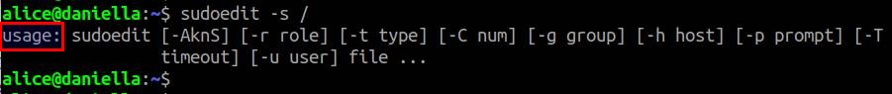

Update sudo Version on Supported Linux Distros
Once you find that your sudo is affected by a known vulnerability, you should update sudo immediately. The easiest way is of course to use the default package manager of your Linux system. However, this method is only applicable if your Linux distro has not reached End-of-Life (EOL). If your Linux distro is no longer maintained because its support lifecycle has expired, the repositories will not be updated with security patches. In this case, you cannot update sudo with a package manager, and you need to update it manually, as described next.
Here I assume that your Linux system is still supported. Before updating sudo, an optional step is to check the changelog of the sudo package to confirm that the sudo package has been patched for a known vulnerability. In this example, the vulnerability under consideration is CVE-2021-3156. You can skip checking the changelog if you are upgrading sudo as part of regular maintenance.

Update sudo on Ubuntu, Debian or Linux Mint:
To check the vulnerability patch for sudo in the changelog of its DEB package:
$ sudo apt update; apt changelog sudo | grep CVE-2021-3156

- debian/patches/CVE-2021-3156-pre1.patch: check lock record size in
- debian/patches/CVE-2021-3156-pre2.patch: sanity check size when
- debian/patches/CVE-2021-3156-1.patch: reset valid_flags to
- debian/patches/CVE-2021-3156-2.patch: add sudoedit flag checks in
- debian/patches/CVE-2021-3156-3.patch: fix potential buffer overflow
- debian/patches/CVE-2021-3156-4.patch: fix the memset offset when
- debian/patches/CVE-2021-3156-5.patch: don't assume that argv is

Once you confirm that the patch is available, go ahead and update sudo with:
$ sudo apt update; sudo apt --only-upgrade install sudo

Note that, even after a successful update, sudo version may remain the same or one of affected versions. Rest assured. It is simply because often times a vulnerability patch is simply backported to an existing sudo version. Thus, to verify the patch is successfully applied, it is recommended to test sudo against the vulnerability, as described previously.

Update sudo on Fedora or CentOS:
To check the vulnerability patch for sudo in the changelog of its RPM package:
$ repoquery --changelog sudo | grep CVE-2021-3156

Fedora 33 openh264 (From Cisco) - x86_64 3.6 kB/s | 3.2 kB 00:00
Fedora Modular 33 - x86_64 952 kB/s | 1.5 MB 00:01
Fedora Modular 33 - x86_64 - Updates 1.5 MB/s | 1.5 MB 00:01
Fedora 33 - x86_64 - Updates 2.0 MB/s | 10 MB 00:05
Fedora 33 - x86_64 1.3 MB/s | 15 MB 00:10
RPM Fusion for Fedora 33 - Free - Updates 1.1 MB/s | 414 kB 00:00
RPM Fusion for Fedora 33 - Free 1.3 MB/s | 964 kB 00:00
- fixed CVE-2021-3156 sudo: Heap buffer overflow in argument parsing

Once you confirm that the patch exists, go ahead and update sudo with:
$ sudo dnf update sudo

Note that, even after a successful update, sudo version may remain the same or one of affected versions. Rest assured. It is because often times a vulnerability patch is simply backported to an existing sudo version. To double check on that, it is always a good idea to re-test sudo against the vulnerability, as described previously.
If your CentOS or Fedora system has reached EOL, you will need to manually update sudo as described next.

Update sudo Version on Unsupported Linux Distros
If you are running an old Linux distribution which has reached EOL and is not supported (e.g., CentOS 6, Ubuntu 17.04), unfortunately you are on your own in regards to applying security patches. For some Linux distros, at least you can download the latest stable version of sudo binary package from the official website. For example, they provide an RPM package of the latest sudo for unsupported RHEL/CentOS 5 and 6.
If a pre-built binary package is not available, you can build the latest stable version (1.9.5p2 as of now) of sudo from the source, and manually install it. You can also consider using CheckInstall to build a DEB/RPM package from the source.
The following describes how to manually build and install sudo from the source.

For Ubuntu, Debian or Linux Mint:
$ sudo apt install make gcc
$ wget https://www.sudo.ws/dist/sudo-1.9.5p2.tar.gz
$ tar -xf sudo-1.9.5p2.tar.gz
$ cd sudo-1.9.5p2
$ ./configure --prefix=/usr
$ make
$ sudo make install

For CentOS or Fedora:
$ sudo dnf install make gcc
$ wget https://www.sudo.ws/dist/sudo-1.9.5p2.tar.gz
$ tar -xf sudo-1.9.5p2.tar.gz
$ cd sudo-1.9.5p2
$ ./configure --prefix=/usr
$ make
$ sudo make install

After installation, verify that sudo is up-to-date:
$ sudo --version

Sudo version 1.9.5p2
Sudoers policy plugin version 1.9.5p2
Sudoers file grammar version 48
Sudoers I/O plugin version 1.9.5p2
Sudoers audit plugin version 1.9.5p2

